How the 12-Factor App Methodology Streamlines Application Development
The 12-factor app methodology specifically created for building Software as a Service (SaaS) apps, while avoiding the headaches that has typically bedeviled long-term enterprise software projects. SitePoint succinctly describes it as “an outline for building well structured and scalable applications.”
These best practices are based on a few specific parameters for deployment of cloud-native applications:
- It uses declarative formats for setup automation.
- It works with a clean contract with the operating system for greater portability between environments
- It limits the differences between development and production, for continuous deployment
- And it allows for scaling up and down without major changes
The 12-factor methodology is programming language agnostic and works with any combo of backing services.
“It’s here to change the way you think and to be able to deliver software faster,” said Mirantis senior solutions architect Greg Pryzby in his talk “You must be 12-factors high to ride,” which he gave at the OpenStack Summit earlier this year:
Open You Must Be 12 Factors High to Ride on YouTube.

The Right Environment
The 12-factor app methodology addresses the following challenges:
- How can you get to fail faster?
- How can you get everything you need ready so then, at a push of a button, you and your team can get your work done?
- How do you take that code and then through process make it available for production?
- And then how can you automate that process with continuous integration, continuous deployment, and even sometimes continuous delivery?
- How do you get people to change methodology? What are the processes that they need to define to do the work?
As with all cultural transformations, answering these challenges could down to three parts: the people, the processes and the tech.
“Understanding the processes and educating the people help us to understand that one side of how do I build an app to identify potholes so they can get fixed,” Pryzby said.

The 12 Building Blocks of 12-Factor Apps

Factor 1: Codebase
You need to build on top of one codebase, fully tracked with revision control and many deployments. Deployments should be automatic, so everything can run in different environments without work.
“If you’re thinking that something is different in dev than in QA, don’t put it in the code,” Pryzby said, echoing a common theme you will see running throughout the 12 factors.

Factor 2: Isolated Dependencies
“How many times have you installed or tried to install something only to find out you had the wrong version of glibc?” asked Pryzby. Or perhaps you had the wrong version of Python or the wrong version of one of the Python libraries?
The second factor is about explicitly declaring and isolating dependencies because the app is a standalone and needs to install dependencies. This is why you declare what you need in the code.
“Your development, your QA and your production have to be identical for 12-factor apps to actually work because when you scale for web, you can’t have any room for error.”

Factor 3: Config
Here you store your configuration files in the environment. This factor focuses on how you store your data — the database Uniform Resource Identifier (URI) will be different in development, QA and production.

Factor 4: Backing Services
You need to treat backing services like attached resources because you may want different databases depending on which team you’re on. Sometimes dev will want a lot of logs, while QA will want less. With this method, even each developer can have their own config file.

Factor 5: Build, Run, Release
You want to strictly separate the Build and Run stages, making sure everything has the right libraries. Then you put everything together in something that can be released and installed in the environment and then be able to run it.
“As a developer, I want to be able to develop something that is this nice, tightly deliverable object, thing, that I can give to Ops. Ops then can put it in that environment and run it. And ideally, I will never hear from Ops again,” Pryzby said, “because you’ve made it a well-defined solution” with few dependencies.

Factor 6: Stateless Processes
You want to make sure that stuff is stored in a backing store, meaning you’re able to scale out and do what you need to do. The app is executed in one or more stateless processes. As you scale up and out, you don’t want to have a state that you need to pass along.

Factor 7: Port Binding
“People are back and forth on how important this is,” admitted Pryzby, but argues exporting services via port binding allows your internal customers to access your endpoints without traversing security. Then, you are able to access your app directly via a port to know if it’s your app or another point in the stack that isn’t working properly.

Factor 8: Concurrency
Small, defined apps allow scaling out as needed to handle the varying loads. Break your app into much smaller pieces and then look for services out there that you either have to write or can consume.

Factor 9: Disposability
Make sure changes can take effect very quickly. It’s about making sure you can start up and take down fast. And that you can handle a crash.

Factor 10: Dev-Prod Parity
Development, staging and production should be as similar as possible. Continuous deployment needs continuous integration based on matching environments to limit deviation and errors. If you keep dev, staging and production as similar as possible, anyone can understand it and release it. This is of course simply good development but it also enables a lot more scalability.

Factor 11: Logs
Your app only worries about creating a sort of event stream. Then, depending on the configuration, you can decide where that log will publish.

Factor 12: Admin Processes
Your admin tools ship with the product. Pryzby warns us to not go messing with the database. Instead, use the tooling you built alongside your app to go and check the database. This also means that the privileges are the same across your system — no more special cases that put your security at risk.

But Who Uses Factor 12?
Of course, factor 12 is only a solution for certain companies. It’s not ready for those that are still trying to overcome the baggage of their legacy, on-premise applications. The right use case for this DevOps methodology is in new apps or instances where you’ve already started the refactoring process for a brownfield project that you’re completely reworking.
It’s all about deciding what your main problem is and if factor 12 can solve that problem. And even devotees of factor 12 don’t always apply all 12 factors. Will Koffel has written a good piece that highlights which factors are mandatory versus very important versus only rather important.
But, when it comes down to it, as always, you should prioritize what works for your team.

Pattern: Command Query Responsibility Segregation (CQRS)

Context
You have applied the Microservices architecture pattern and the Database per service pattern. As a result, it is no longer straightforward to implement queries that join data from multiple services. Also, if you have applied the Event sourcing pattern then the data is no longer easily queried.

Problem
How to implement a query that retrieves data from multiple services in a microservice architecture?

Solution
Define a view database, which is a read-only replica that is designed to support that query. The application keeps the replica up to data by subscribing to Domain events published by the service that own the data.

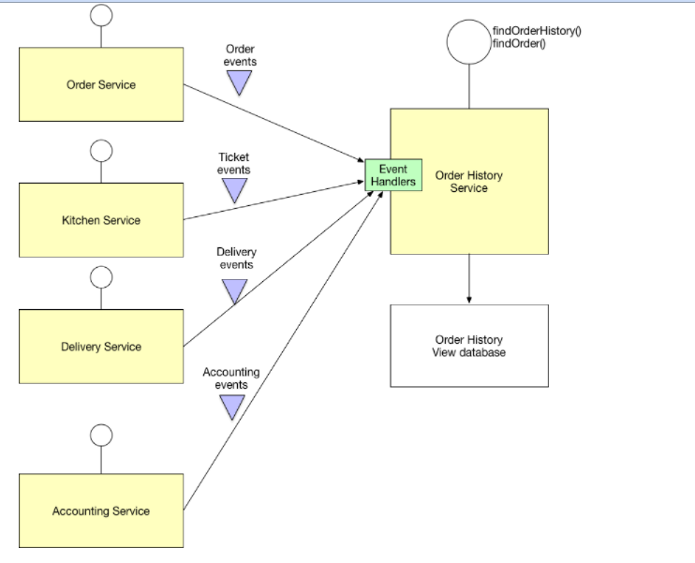Examples
- My book’s FTGO example application has the Order History Service, which implements this pattern.
- There are several Eventuate-based example applications that illustrate how to use this pattern.

Resulting context
This pattern has the following benefits:
- Supports multiple denormalized views that are scalable and performant
- Improved separation of concerns = simpler command and query models
- Necessary in an event sourced architecture
This pattern has the following drawbacks:
- Increased complexity
- Potential code duplication
- Replication lag/eventually consistent views

Related patterns
- The Database per Service pattern creates the need for this pattern
- The API Composition pattern is an alternative solution
- The Domain event pattern generates the events
- CQRS is often used with Event sourcing

